# **CSC289 Programming Capstone Project**

**Project Name:** TRACE

**Team Number:** 14

**Team Project Manager:** Stephen Strong

**Team Members:** Alexi McNabb, Dylan Arone

**Mentor:** Cindy Luttrell

**Software Installation Guide: TRACE**

**Introduction**

Brief Introduction of Program: The application takes forms 1040, 1099, and W-2 as input for its calculations. The application does not consider any dynamic values as all calculations are done offline. The application accepts input and displays output through a simple form interface. The application will only handle standardized deductions and not additional tax credits.

The application uses SQLite database files as a portable means of saving the user’s input and its own output for later use. Multiple files can be opened in multiple instances of the application.

Purpose of Installation Guide:

* Simplified Installation: This manual simplifies difficult installation procedures into clear directions. Installing, uninstalling, and upgrading the software is made simple and straightforward for all users, regardless of expertise level.
* Improved Understanding: By providing information about the software's functionality, this guide helps users better comprehend the underlying technology. It encourages self-sufficiency by giving users the ability to configure the software on their own.
* Error Prevention: Instructions that are clear can help users avoid common installation difficulties and errors. Carefully following the instructions reduces the likelihood of problems for users.
* Good User Experience: Having an installation manual available helps make the user experience better overall. User satisfaction increases when consumers can install the software successfully.

**System Requirements**

* Operating System: Windows 10 or later
* Processor: Intel Core i5 or newer
* RAM: 8 GB or more
* Disk Space: 1 GB or more free space
* Monitor/Display with 1920x1080p minimum resolution and 2160x1440p maximum resolution
* Trace Installer
* Browser app capable of viewing/opening PDFs, For Example chrome, Firefox, Edge, etc.
* Browser capable of surfing the web
* May need to turn off windows defender to allow installation of exe.
* Internet Connection: Required for installation and updates

**Downloading the Installer**

* Download TRACE Installer
  + Visit the official GitHub pages of TRACE at [GitHub - ssstrong1/Group_14_TRACE: TRACE Project](https://github.com/ssstrong1/Group_14_TRACE)
  + You can click Code and click download zip: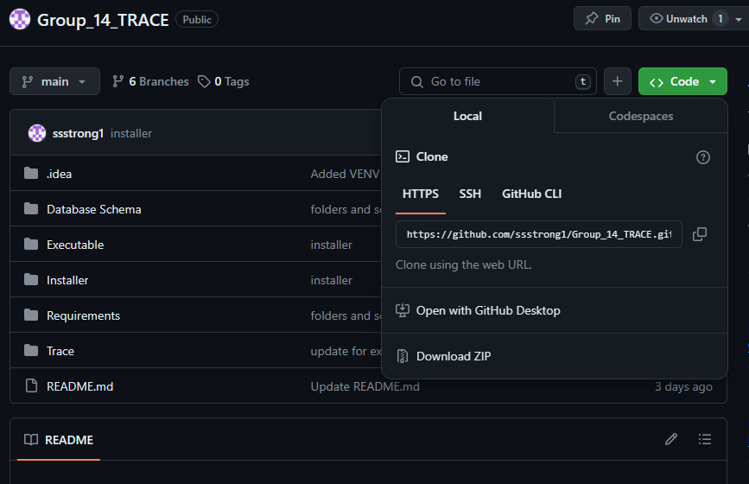You can also click on TRACE Release under Releases: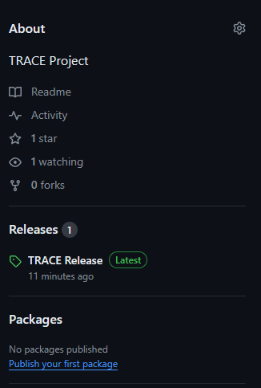 Then click on source code (zip). Optionally, you can follow the instructions below for an alternative
  + If you don't want to download the zip, instead navigate to the "Installer" Folder.
  + From here you can click on tracesetup.exe, then click on the three dots in the right-hand corner and click download: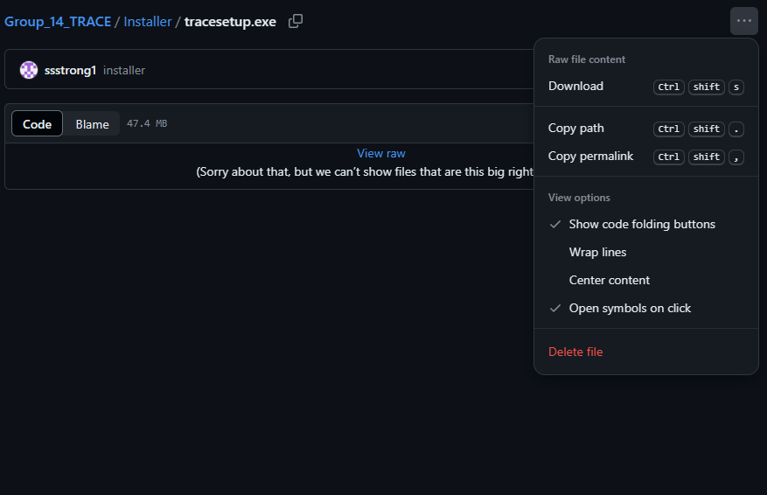Make sure to check your browser downloads area. If you get this message: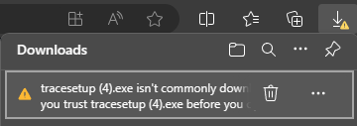 make sure to click on the three dots next to your file and select keep. This message will pop up next: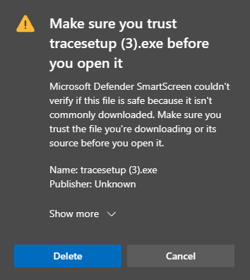 Select Show more and select Keep anyway. Your file should now be downloaded.

**Download Troubleshooting**

* If you get this message: Navigate to your windows security.
* From there click Virus and Threat Protection: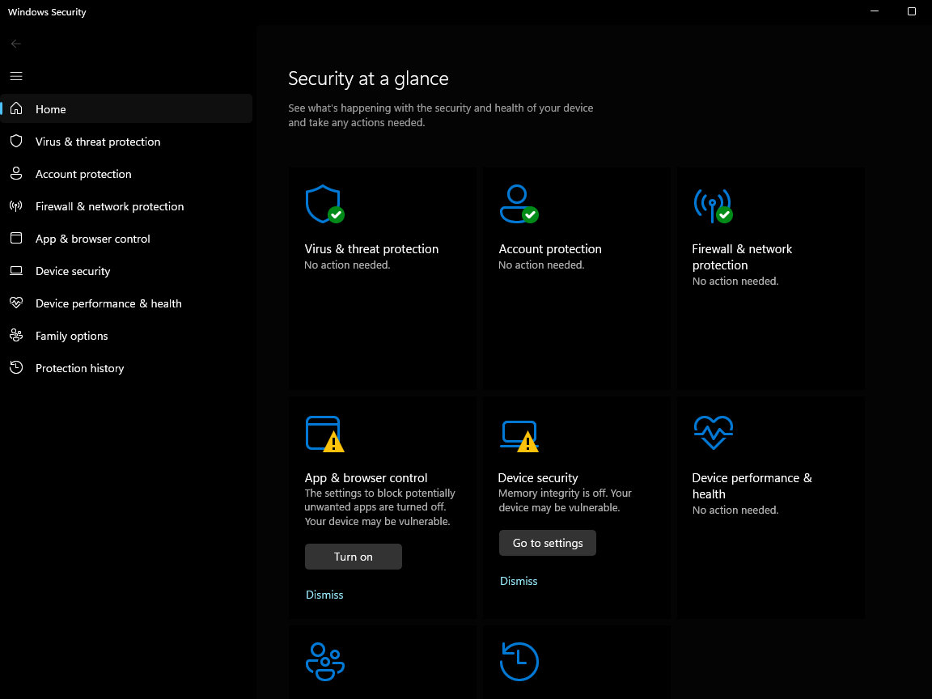
* Then click Protection History: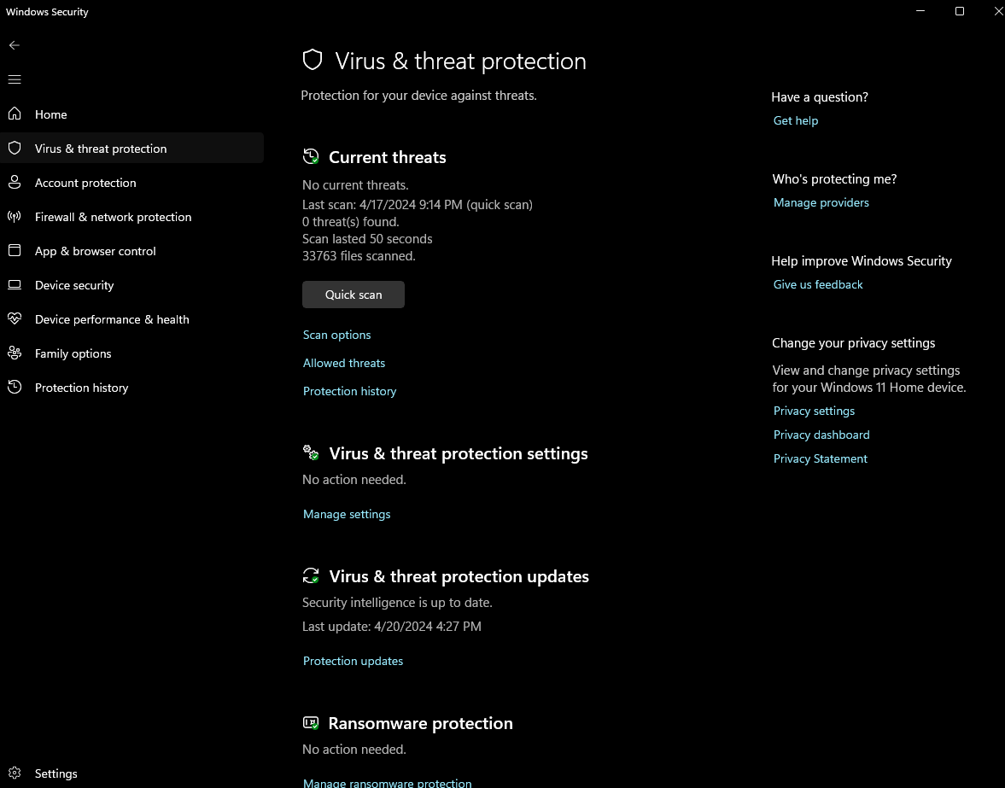
* Next Navigate to the file that was blocked:

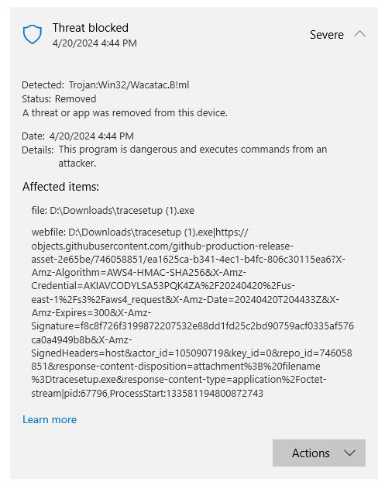 and select actions then restore. Your download is now restored and ready to be used. Navigate to your download folder and see that it is accessible now: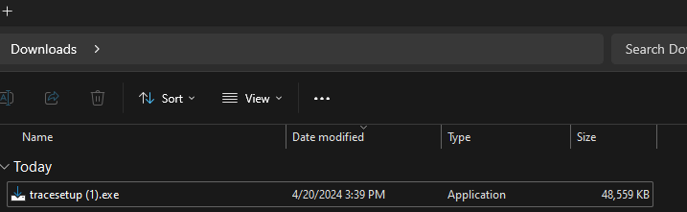

**Installing the Software**

* Running the Installer File with the Zipped Folder
  + Find the downloaded zip folder (either Group_14_TRACE-main.zip or Group_14_TRACE-1.0.0.0.zip if installed from releases) in your system's Downloads folder.
  + Double-click on the zipped folder and extract the contents
  + Navigate to your new extracted folder and inside locate tracesetup.exe in the installer folder
  + Double-click on the installer file (tracesetup.exe) to run it
* Follow the Installation Wizard
  + The installation wizard will help you through the installation process.
  + Choose the installation directory where you want to install TRACE.
  + Click "Next" to proceed with the installation.
* Complete the Installation
  + Once the installation is complete, click "Finish" to exit the installation wizard.
  + TRACE is now installed on your system and ready to use.
* Running the Installer File without the Zipped Folder
  + Find the downloaded installer file (tracesetup.exe) in your system's Downloads folder.
  + Double-click on the installer file to run it.
* Follow the Installation Wizard
  + The installation wizard will help you through the installation process.
  + Choose the installation directory where you want to install TRACE.
  + Click "Next" to proceed with the installation.
* Complete the Installation
  + Once the installation is complete, click "Finish" to exit the installation wizard.
  + TRACE is now installed on your system and ready to use.

**Launching the Software**

* There are two options to running the application.
* 1st you can right click on the TRACE icon inside the location where you installed it and select run as an administrator
* 2nd you can right click on the TRACE icon inside the location where you installed it and click on properties: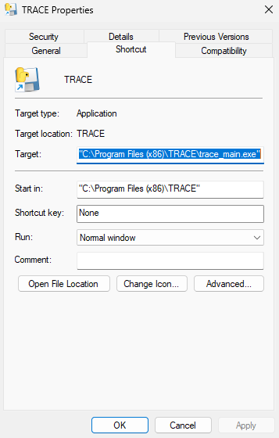
* From there you can customize how you run the program by selecting the compatibility tab and choosing run this program as an administrator and clicking apply: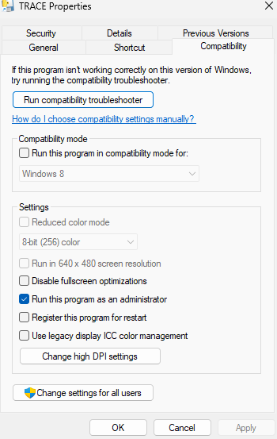
* If you opted to create a Desktop Shortcut you can now double-click it from your Desktop and use the program if you have changed the mentioned settings for the program
* If you have not changed the settings for the program, then you will need to right-click the application and run it as an administrator every time.
* If you are logged in as an administrator, then you do not need to right-click the program and do any of the above. All you need to do is double click the application to run it.
* Alternatively, you can find trace_main.exe in the Program Files (x86)/TRACE.

**Uninstalling the Software**

* Open the Control Panel.
* Go to "Programs" or "Programs and Features."
* Find TRACE version 1.0.0.0 in the list of installed programs.
* Click on TRACE version 1.0.0.0 and select "Uninstall."
* Follow the on-screen prompts to complete the uninstallation process.
* Alternatively, you can just delete the folder where it is installed

**Troubleshooting**

* If you have installed everything correctly but cannot see what you downloaded or installed, you will have to restore it from windows defender see Downloading the Installer (Download Troubleshooting) and follow the steps provided or install it as an administrator. In many cases windows defender flags many apps as viruses when they currently are not.
* Once logged in, if you are not using the recommended resolutions settings you may want to change them for proper use of the application.
* If you get an error message such as (this program does not have the elevated level it needs or something else) it is because you are not running it as an administrator.
* If you are the application loads but you cannot create a new user, it is because you are not running it as an administrator.

**Support and Contact Information**

Links:

* [Unable to Install Apps or Software on Windows? Here's What to Do (makeuseof.com)](https://www.makeuseof.com/tag/try-windows-software-wont-install/)
* [Top 6 Ways to Fix Unable to Install Programs or Software on Windows 11 - Guiding Tech](https://www.guidingtech.com/top-ways-to-fix-unable-to-install-programs-or-software-on-windows-11/)
* [Windows 11 common problems — and the fixes | Windows Central](https://www.windowscentral.com/windows-11-common-problems-and-fixes)
* [9 Ways to Fix Unable to Install Apps or Software on Windows 11 - Gadgets To Use](https://gadgetstouse.com/blog/2022/05/23/9-ways-to-fix-unable-to-install-apps-or-software-on-windows-11/)

Contact Information:

Project Manager: Stephen Strong – ssstrong@my.waketech.edu

User Interface Specialist: Alexi Mcnab - acmcnabb@my.waketech.edu

Back-End Specialist: Dyaln Arone - daarone@my.waketech.edu